
School of ComputerScience and ArtificialIntelligence LabAssignment-9.1

Problem 1:ConsiderthefollowingPythonfunction:
deffind_max(numbers):
returnmax(numbers) Task:
- Writedocumentationforthefunctioninallthreeformats:
- Docstring
- Inlinecomments
- Google-styledocumentation
- Criticallycomparethethreeapproaches.Discussthe advantages,disadvantages,andsuitableusecasesofeach style.
- Recommendwhichdocumentationstyleismosteffectiveforamathematicalutilitieslibraryandjustifyyouranswer.

SCREENSHOTOFGENERATEDCODE:
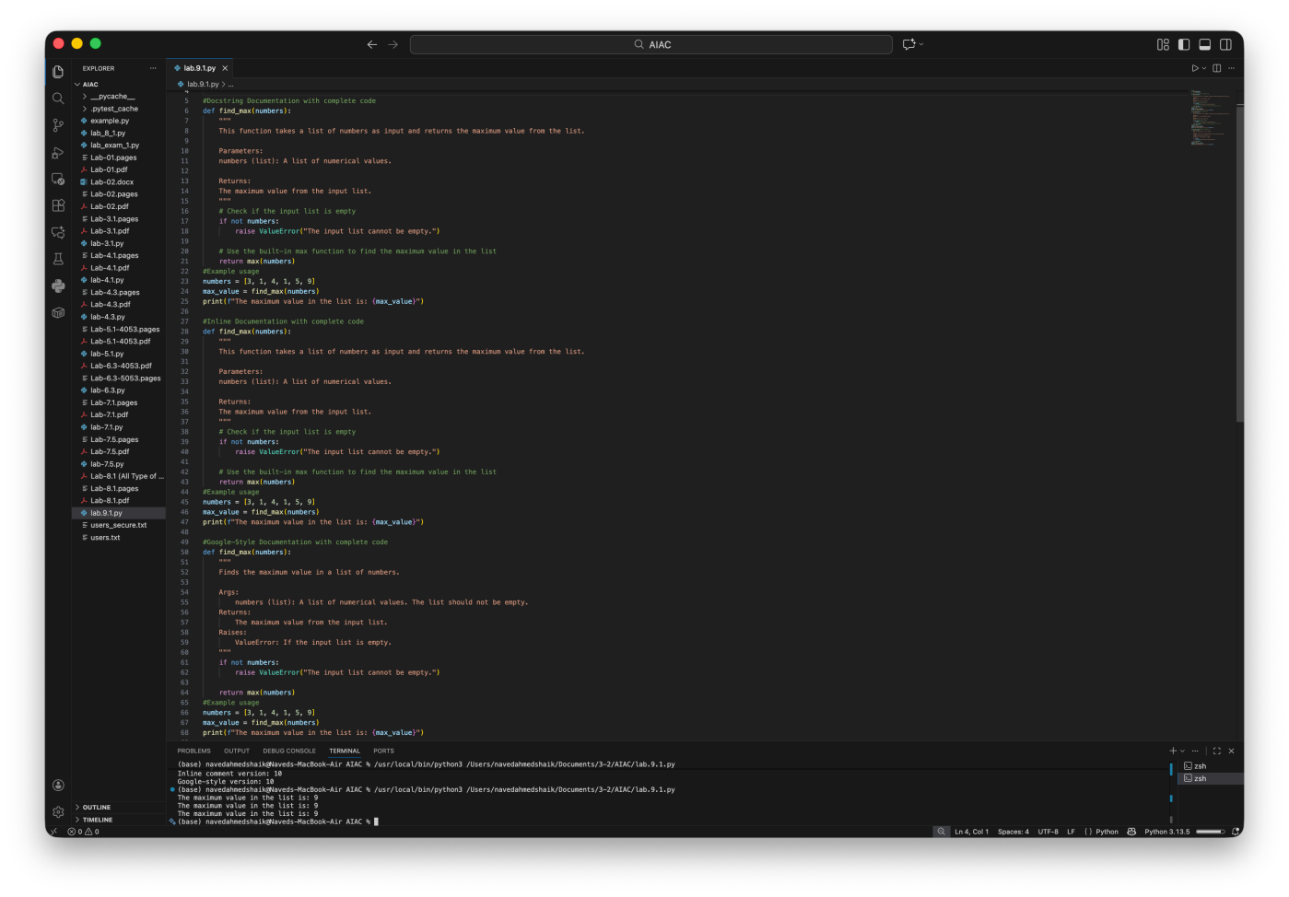

EXPLANATION:
The function `find_max` takes a list of numbers as input and returns the maximum value from that list. It first checks if the input list is empty and raises a ValueError if it is. If the list is not empty, it uses the built-in `max` function to find andreturnthemaximumvalue.Thefunctionisdocumentedusingthreedifferentstyles:docstringdocumentation,inline documentation, and Google-style documentation, providing clear explanations of the function's purpose, parameters, return value, and potential exceptions.

Style | Advantages | Disadvantages | SuitableUseCases
Docstring (standard) | Simple,readable,builtintoPython help tools | Lessstructuredthan formal styles | Small scripts, educationalcode
Inline comments | Explainlogicstep-by-step | Cancluttercode,not accessibleviahelp() | Complexalgorithms needing explanation
Google- style | Highlystructured,professional, IDE-friendly, good for teams | Slightlylonger to write | Libraries,APIs, productioncode

Problem2:ConsiderthefollowingPython function:
deflogin(user,password,credentials):
returncredentials.get(user)==password Task:
- Writedocumentationinallthreeformats.
- Critically compare the approaches.
- Recommendwhichstylewouldbemosthelpfulfornew developers onboarding a project, and justify your choice.

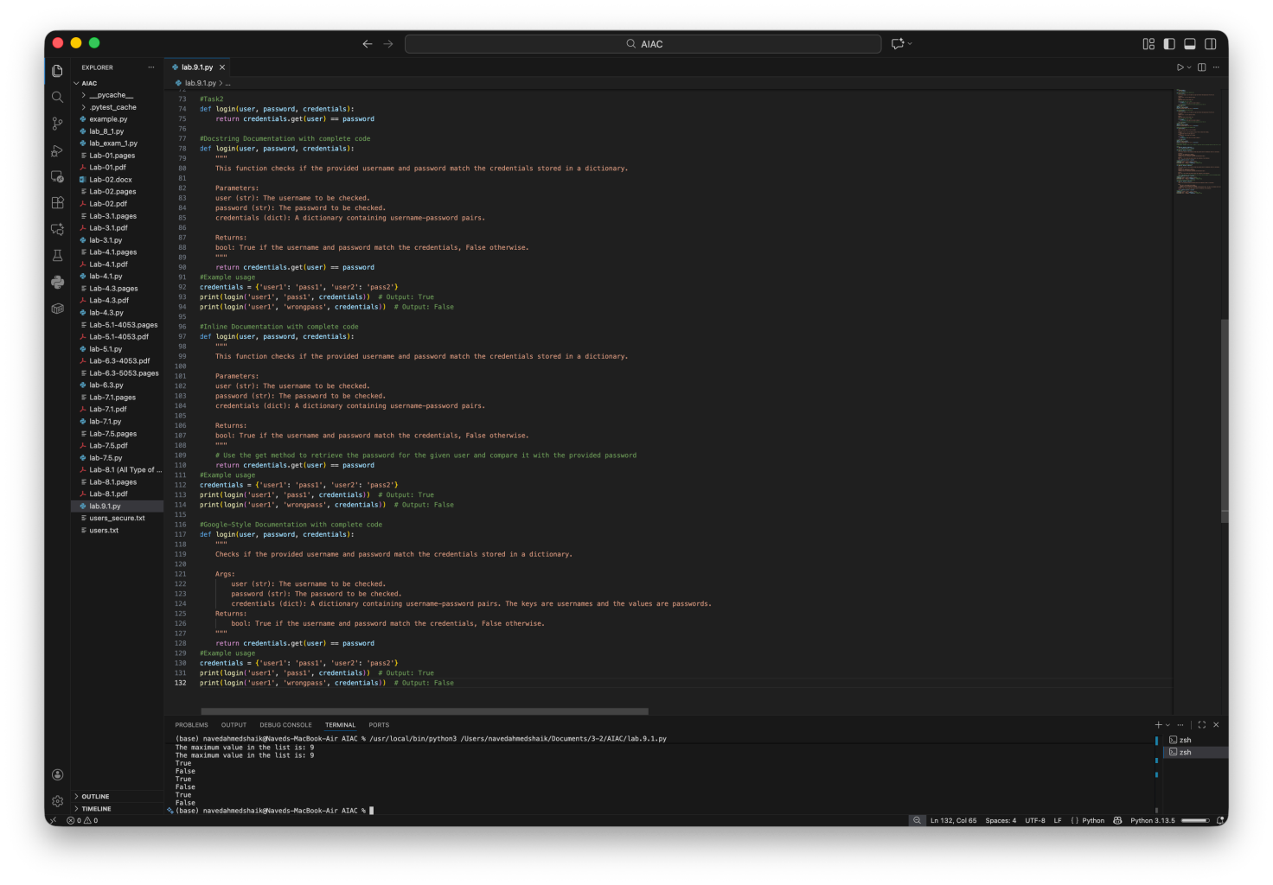
SCREENSHOTOFGENERATEDCODE:

EXPLANATION:
The function `login` takes three parameters: `user`, `password`, and `credentials`. It checks if the provided username and password match the credentials stored in a dictionary. The function uses the `get` method of the dictionary to retrievethepasswordassociatedwiththegivenusernameandcomparesitwiththeprovidedpassword.Iftheymatch,it returns `True`; otherwise, it returns `False`. The function is documented using three different styles: docstring

documentation,inlinedocumentation,andGoogle-styledocumentation,providingclearexplanationsofthefunction's purpose, parameters, return value, and potential exceptions.

Style | Advantages | Disadvantages | BestUseCases
Docstring (standard) | Simple,readable,builtinto Python help tools | Lessstructuredfor large projects | Smallscripts,student projects
Inline comments | Explainlogicdirectlynearcode | Notvisibleviahelp(), can clutter code | Complexinternallogic explanation
Google-style | Structured,professional,IDE- friendly, great for teams | Slightlylonger to write | Libraries,APIs, collaborativeprojects

Problem3:Calculator(AutomaticDocumentation Generation)
Task:DesignaPythonmodulenamedcalculator.pyanddemonstrateautomaticdocumentationgeneration. Instructions:
- Create a Python module calculator.py that includes the followingfunctions,eachwrittenwithappropriatedocstrings:
oadd(a, b) –returns the sumof two numbers
osubtract(a,b)–returns thedifferenceoftwo numbers
omultiply(a, b) –returns the productof two numbers
odivide(a, b) –returns the quotientof two numbers
- DisplaythemoduledocumentationintheterminalusingPython’sdocumentationtools.
- GenerateandexportthemoduledocumentationinHTMLformatusingthepydocutility,andopenthegenerated HTML file in a web browser to verify the output.

SCREENSHOTOFGENERATEDCODE:

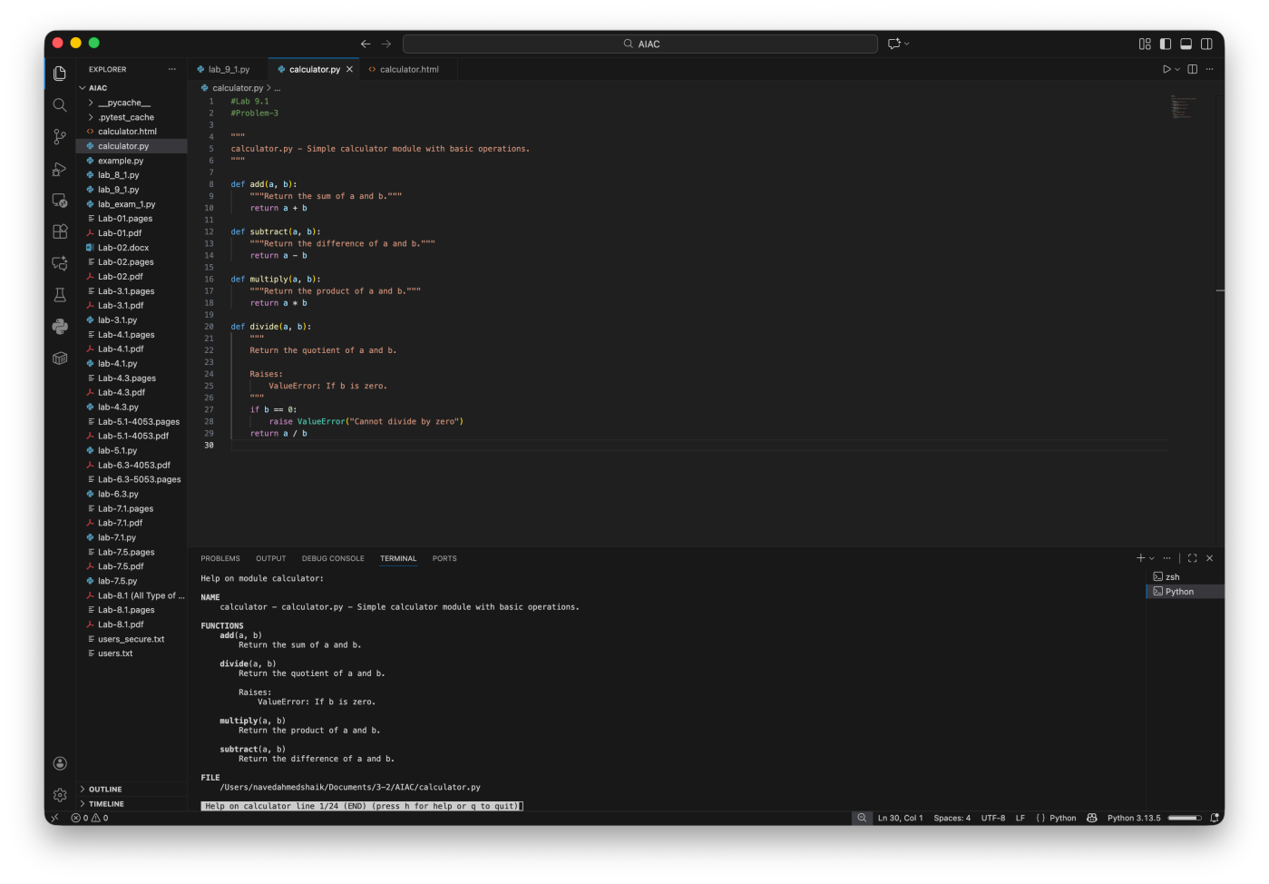

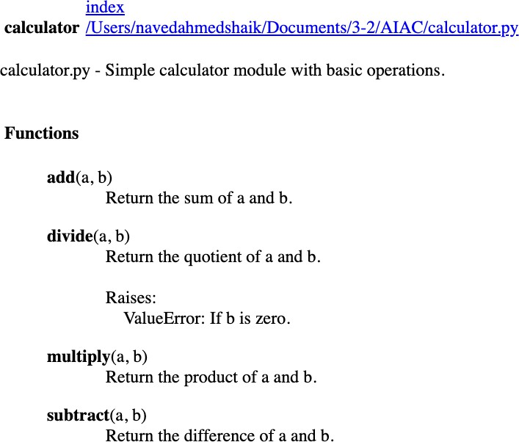

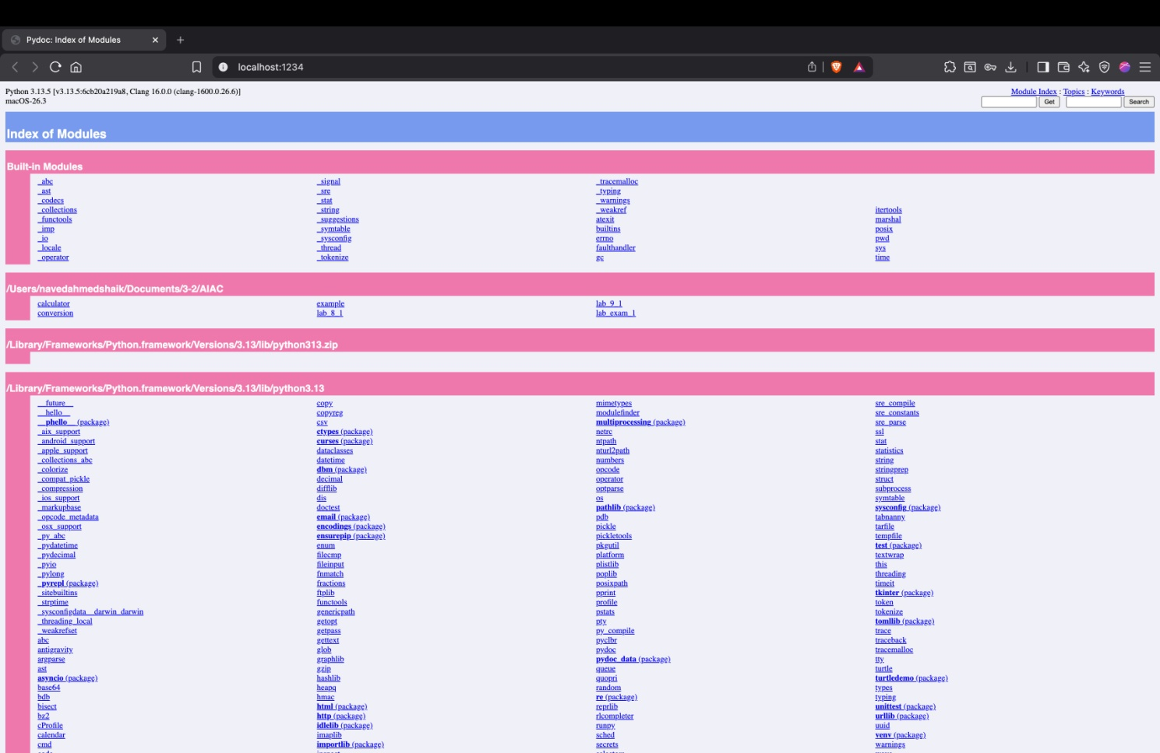

Problem4:ConversionUtilitiesModule
Task:
- Writeamodulenamedconversion.pywithfunctions:
o decimal_to_binary(n)
o binary_to_decimal(b)
o decimal_to_hexadecimal(n)
- Use Copilot for auto-generating docstrings.
- Generate documentation in the terminal.
- Exportthe documentation in HTMLformat and open it in a browser.

SCREENSHOTOFGENERATEDCODE:
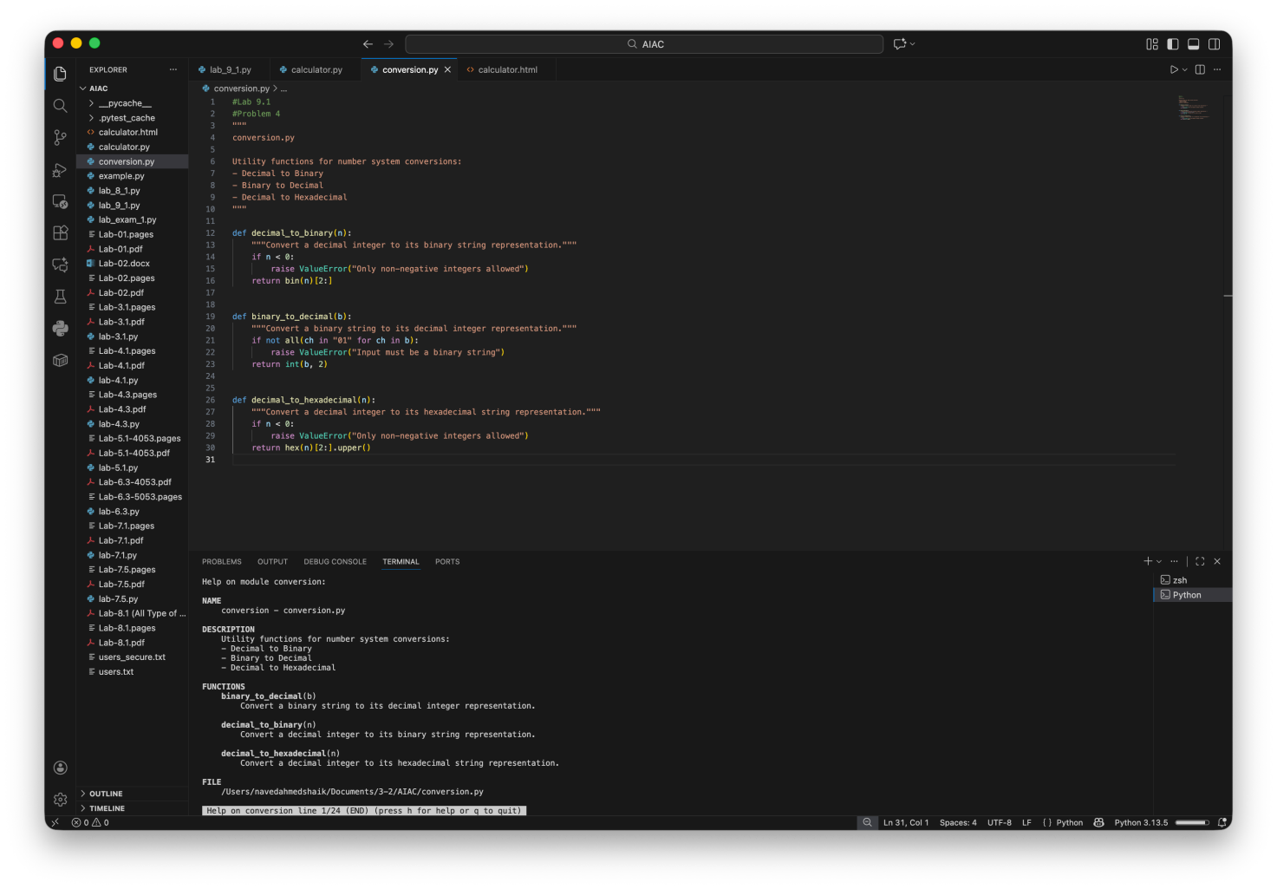

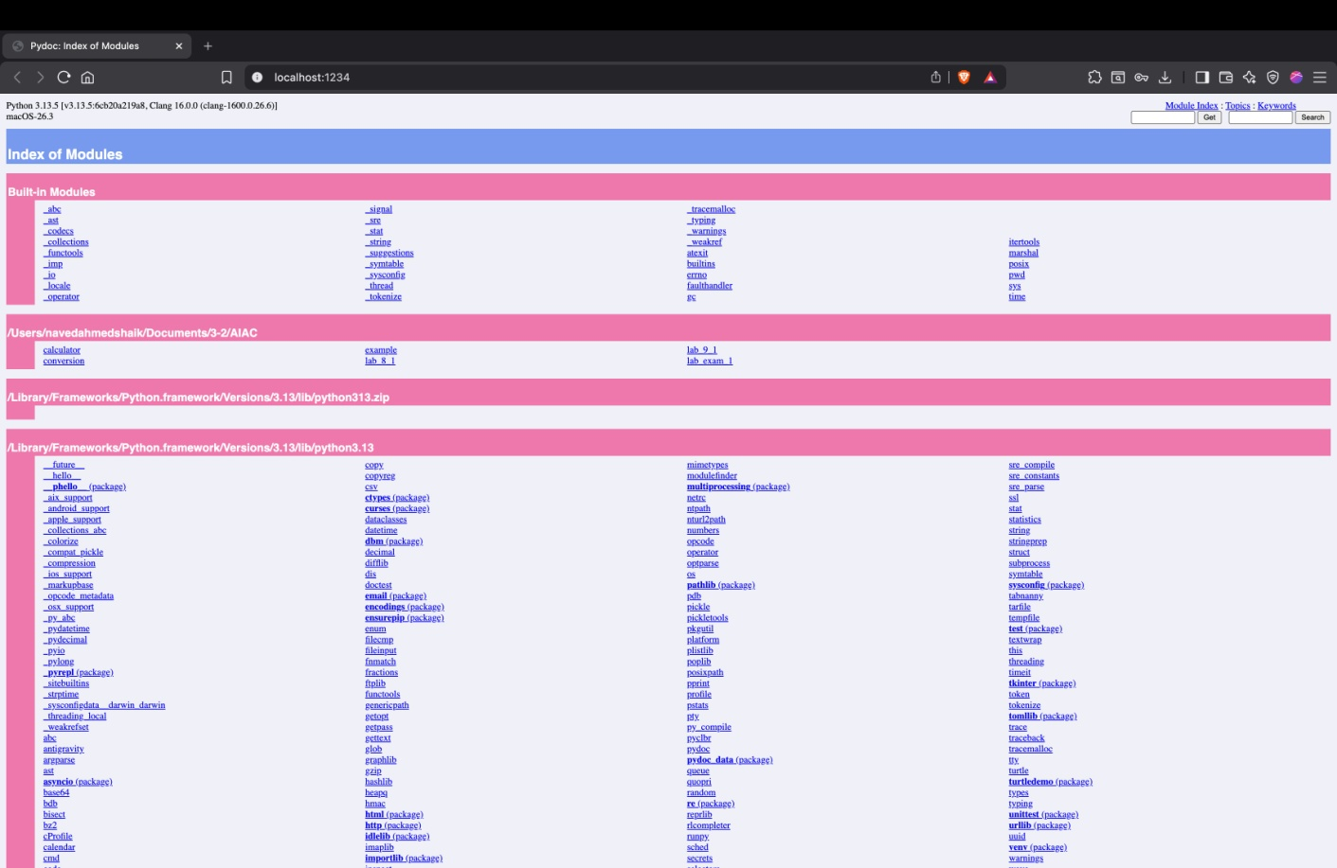

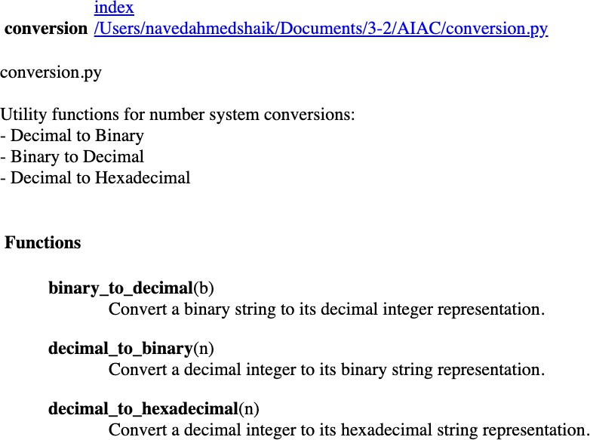

Problem5–CourseManagement Module
Task:
- Createamodule course.pywith functions:
oadd_course(course_id,name, credits)
o remove_course(course_id)
o get_course(course_id)
- Adddocstringswith Copilot.
- Generate documentation in the terminal.
- Exportthe documentation in HTMLformat and open it in a browser.

SCREENSHOTOFGENERATEDCODE:

